**Spring 2016**

**BIOL241 – Introduction to Genetics**

**and Molecular Biology**

**Midterm III (100 points)**

**4/7/2016**

**Name:____________KEY______________________**

**Purdue ID:__________________________________**

Question A: (54) Question B: _ (5)

Question C: (4) Question D: _ (6)

Question E: (11) Question F: _ (4)

Question G: (6) Question H: _ (10)

**Total:**

**A. Multiple-choice questions (54 points, 2 points each, please use a scantron sheet for part A).**

**1) While analyzing the function of an unknown eukaryotic gene, you noticed that it contains leucine zippers. Based on this information, this gene is likely to:**

1. Code for a microRNA.
2. Regulate alternative splicing.
3. Code for a protein that forms dimers.
4. Code for a protein that binds to translational regulatory elements.
5. Code for a protein that repairs DNA.

**2) Functional *transformer* (*tra*) proteins are made in *Drosophila* females, but not in males. This is accomplished by:**

1. The binding of male-specific or female-specific Dsx (double sex) transcription factor to Tra promoter.
2. The binding of Dsx microRNA to Tra mRNA.
3. The binding of Sxl mcroRNA to Tra mRNA.
4. The Sxl-mediated alternative splicing.
5. The sex-specific methylation Tra promoter by Sxl.

**3) Regarding siRNA, which of the following statements is correct?**

1. The RISC complex cleaves injected-dsRNA into short 21 base pairs of dsRNA.
2. siRNA usually binds to target mRNA at specific sites in the 3’ UTR.
3. siRNA usually binds to target mRNA at specific sites in the coding sequence.
4. siRNA mediates gene silencing by predominantly inhibiting translation.
5. siRNA mediates gene silencing by degrading target mRNA.

**4) The Ames test demonstrates that:**

1. Spontaneous mutations are random.
2. Certain chemicals, after processed by liver enzymes, are mutagenic.
3. Transcription factors bind to DNA at specific sequences.
4. Nucleosomes in eukaryotic chromosomes can be remodeled.
5. Certain proteins are capable of interacting with each other in vivo.

**5) The human disease xeroderma pigmentosum is caused by disruption of:**

1. Base excision repair pathway.
2. SOS response.
3. Homologous recombination repair pathway.
4. Mismatch repair pathway.
5. Nucleotide excision repair pathway.

**6) Which of the following events is most likely to cause frameshift mutations?**

1. Tautomeric shifts.
2. Deamination of cytosines.
3. Depurinations.
4. Treating cells with base analogs.
5. Treating cells with intercalating agents.

**7) Which of the following depicts the chain terminating nucleotide used in Sanger sequencing? D**

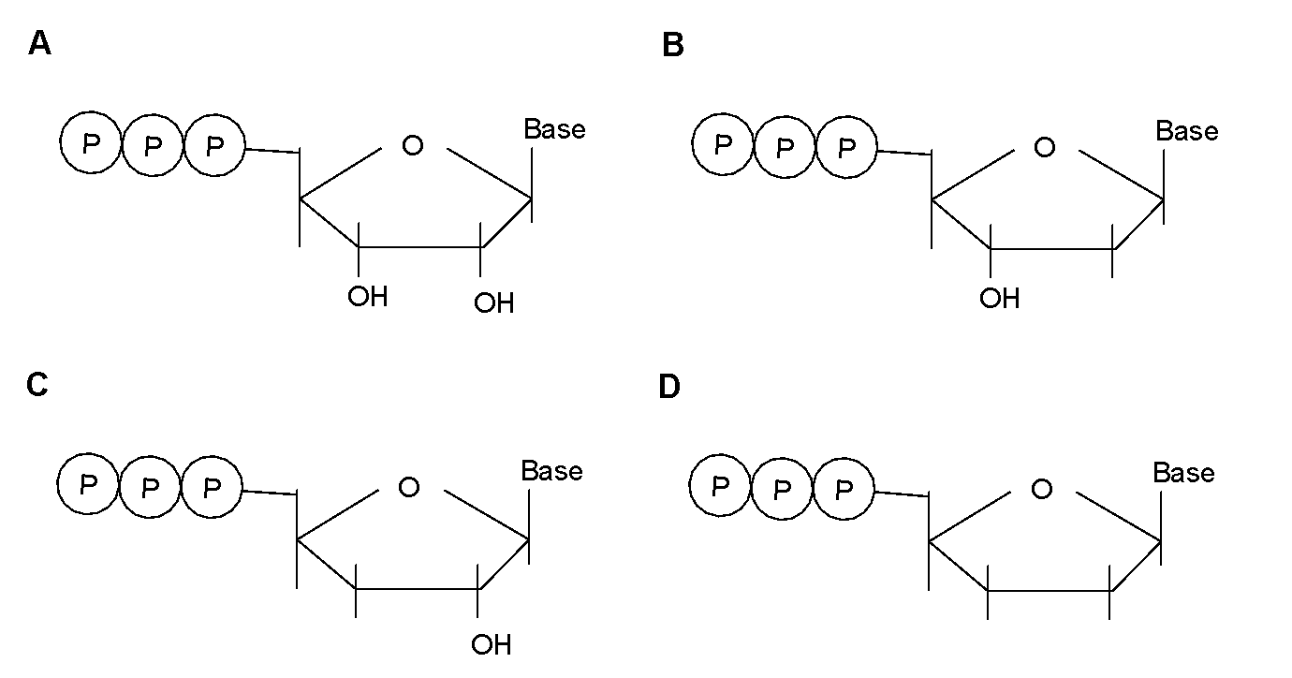

**8) You are entrusted with the task of sequencing the genome of a new species. After screening through a genomic library (made from this species) and analyzing the clones by map-based approach, you have assigned 9 clones (represented by thin lines in the figure below) to a particular chromosome (represented by the thick line).** 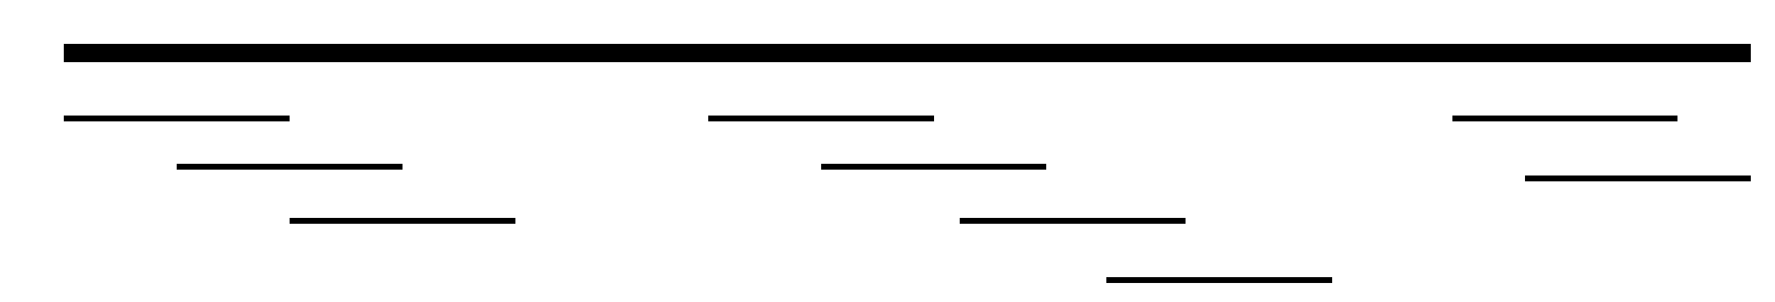

**After compiling the sequences from all 9 clones, you should establish:**

1. 1 contig.
2. 2 contigs
3. 3 contigs.
4. 4 contigs.
5. 9 contigs.

**9) A microarray (gene-chip) experiment is useful for:**

1. Detecting RFLP between two homologous chromosomes.
2. Detecting homologous genes between two species.
3. Detecting phosphorylation targets of a particular kinase.
4. Determining the possible alternative sliced isoforms from a particular gene.
5. Comparing the level of mRNA of different genes between cells at two different states.

**10) Which of the following statements best describes the generation of expressed sequence tags (ESTs)?**

1. Sequencing of transcription factor-bound DNA.
2. Sequencing ends of genomic DNA clones.
3. Sequencing of gaps between contigs.
4. Sequencing ends of cDNA clones.
5. Sequencing of genomic DNA clones from euchromatic regions.

**11) In *Drosophila*, mutants generated by engineered P-elements allow the technique of plasmid rescue. The goal of this technique is to:**

1. Position the gene functions along a pathway.
2. Determine whether the mutations are loss-of-function or gain-of-function.
3. Recover the genomic DNA flanking the inserted P-element.
4. Mobilize the P-elements to insert transposons into new locations.
5. Purify the mRNA from rRNA and tRNA.

**12) Comparing genomes from various prokaryotic species, which of the following statements is correct?**

1. Prokaryotic organisms contain mostly linear chromosomes.
2. Different prokaryotic organisms contain similar amount of genomic DNA.
3. Genes in prokaryotic organisms are always expressed as single-gene mRNAs.
4. Genes in prokaryotic organisms contain introns.
5. Prokaryotic genomes contain few repetitive sequences.

**13) The genome size of *Staphylococcus aureus*, a gram-positive bacterium, is 2.88mb (106 bases). Based on the comparison of prokaryotic genomes, the number of genes in *Staphylococcus aureus* is expected to be:**

1. 28000.
2. 14000.
3. 4000.
4. 2800.
5. 1400.

**14) Horizontal gene transfer is likely facilitated by:**

1. Transposon-mediated DNA movement from one chromosome to a non-homologous chromosome.
2. The transfer of DNA from agarose gel onto nitrocellulose membrane.
3. The transformation by DNA from closely related species.
4. The detection of clones containing specific DNA on nitrocellulose membrane with radioactively labeled probes.
5. The mating between F+ and F- bacterial strains.

**15) Which of the following statements is an example of synteny?**

1. α and β globin genes show similarities in their amino acid sequences.
2. α and β globin genes show similarities in the intron positions.
3. α and β globin genes exhibit different temporal regulations of their respective expressions.
4. *E. coli* and *B. subtilis* exhibit similar gene density.
5. Rice and sorghum show similarities in the order of genes along the chromosomes.

**16) Comparing gene density, which of the following statements is correct?**

1. Genomes of different prokaryotic species have similar gene densities.
2. Eukaryotic genomes on average have higher gene density (number of genes/kb) than the prokaryotic genomes
3. Genomes of different eukaryotic species have similar gene densities.
4. Gene density is uniform along different human chromosomes.
5. Gene density is uniform along each human chromosome.

**17) Comparing human and *C. elegans* genomes, which of the following features is similar?**

1. The amount of DNA.
2. The number of genes.
3. The number of introns per gene.
4. The average size of introns.
5. The number of identified protein domains.

**18) When using 2D gels to separate the cellular proteins, the proteins are first separated by:**

1. Their molecular weights.
2. Their ability to bind to DNA.
3. Their mass-to-charge ratios.
4. Their electric charges.
5. Their ability to form disulfide bonds.

**19) When a haploid *petite* mutant mates with haploid normal yeast, the resulting diploid zygote exhibits the normal phenotype. After sporulation (meiosis), all haploid progeny are normal. This pattern of inheritance describes:**

1. Segregational petite.
2. Neutral petite.
3. Suppressive petite.
4. Haploinsufficient.
5. Dominant negative.

**20) A different yeast *petite* mutant is isolated. To determine the type of mutation causing this phenotype, the haploid *petite* and wild type strains are crossed. The diploid zygotes are petite, and all the haploid ascospores after sporulation are petite. The explanation for this mutation is that**:

1. It disrupts a nuclear gene that participates in mitochondrial function.
2. The inheritance of mitochondrial genome in yeast is strictly maternal.
3. The inheritance of mitochondrial genome in yeast is strictly paternal.
4. It affects mitochondrial genes, which disrupt mitochondrial function, but gives normal mitochondria proliferation advantage.
5. It affects mitochondrial genes, which disrupt mitochondrial function, but gives defective mitochondria proliferation advantage.

**21) Regarding mitochondrial genomes, which of the following statements is incorrect?**

1. The mitochondrial genome is a circular DNA.
2. Human mitochondrial genome contains ~17kb of DNA.
3. Most of the mitochondrial proteins are encoded by the mitochondrial genome.
4. The inheritance of mitochondrial genome in human is maternal.
5. The mitochondrial genome encodes genes that are critical for energy metablism.

**22) The ChIP (chromatin immunoprecipitation) assays will identify:**

1. The differences in mRNA abundances of different genes between cells at two different states.
2. The differences in restriction sites between two homologous chromosomes.
3. The protein-protein interactions.
4. The sequences of transcription enhancer elements.
5. The sequences of intron/exon boundaries of different genes.

**23) You are asked to sequence a DNA template using Sanger’s method. The sequence of the template is:**

5’- GTCGAGTCACGCGGACCTGGTCTCGAACATTGTCCGAATTGCCGATCGGATC -3’

3’- CAGCTCAGTGCGCCTGGACCAGAGCTTGTAACAGGCTTAACGGCTAGCCTAG -5’

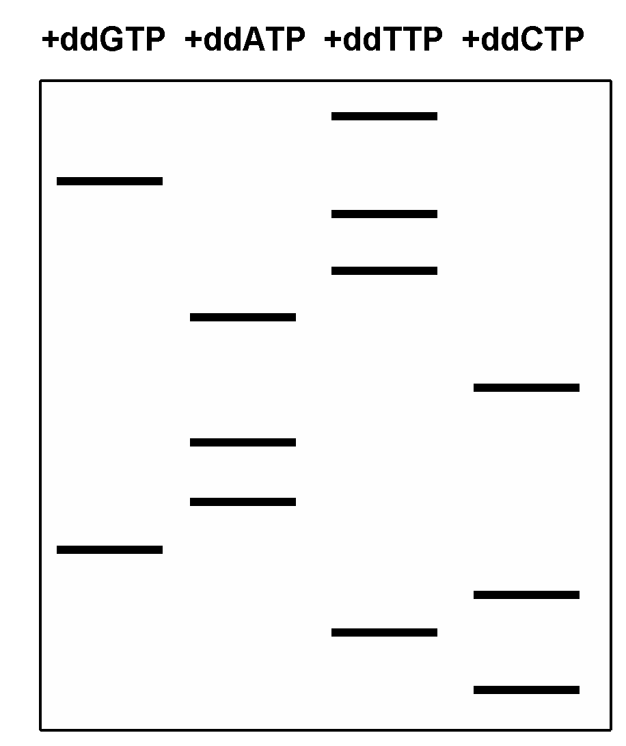

**The result is shown in the gel below.**

**Which the following could be a primer for this reaction?**

1. 5’- GTCGAGTCACGC -3’
2. 5’- GCCGATCGGATC -3’
3. 5’- GATCCGATCGGC -3’
4. 5’- CAGCTCAGTGCG -3’
5. 5’- CTAGGCTAGCCG -3’

**24) The following linear DNA template needs to be amplified using PCR, which of the following primer pairs should be used?**

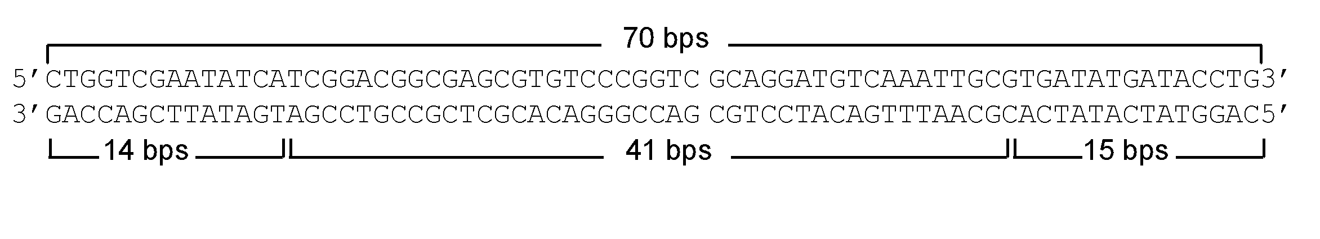

1. 5’-CTGGTCGAATATCA-3’ and 5’-GTCCATAGTATAGTG-3’
2. 5’-CTGGTCGAATATCA-3’ and 5’-CAGGTATCATATCAC-3’
3. 5’-CTGGTCGAATATCA-3’ and 5’-GTGATATGATACCTG-3’
4. 5’-GACCAGCTTATAGT-3’ and 5’-GTCCATAGTATAGTG-3’
5. 5’-GACCAGCTTATAGT-3’ and 5’-CAGGTATCATATCAC-3’

**25) Which of the following techniques will be useful for identifying proteins that physically bind to protein-of-interest?**

1. Yeast 2-hybrid screen.
2. Luria and Delbruck fluctuation test.
3. 2-dimentional gel.
4. Microarray analysis.
5. Epitasis test.

**26) To generate mouse mutants by homologous recombination, researchers often make a targeting construct, which contains a flanking thymidine kinase gene. The purpose of this thymidine kinase gene is to:**

1. Mediate the transposition of the targeting construct when it is integrated into the ES cell genome.
2. Serve as a marker to selecting ES cells with constructs integrated by homologous recombination.
3. Increase the efficacy of construct integration into the embryonic stem (ES) cell genome.
4. Increase the likelihood that transfected ES cells become germ cells when injected into blastocyst.
5. Serve as a selectable marker for the presence of the targeting construct in the ES cell genome.

**27) In using the CRISPR/Cas system for genomic editing, the specificity of Cas9 is controlled by?**

1. Palindromic restriction sites.
2. MicroRNA.
3. Flanking direct repeats.
4. Flanking inverted repeats.
5. Guide RNA.

**B) Based on the lectures, please complete the following table (5 points):**

|  |  |  |
| --- | --- | --- |
| **Type of mutagen** | **Example of the mutagen** | **Genetic lesion(s) induced** |
| UV light | UV light | T^T dimers |
|  | Ethylmethane sulfonate (EMS) |  |
|  | X ray |  |
| Base analog |  | Point mutations |

**C) Based on the lectures, please complete the following table (4 points):**

|  |  |  |
| --- | --- | --- |
| **Type of genetic lesion** | **Repair system** | **Component of the system** |
| Double-stranded breaks | Homologous recombination repair | RecA |
| T^T dimers |  | UvrABC |
|  |  | Uracil DNA glycosylase |
| Incorrectly inserted nucleotides | “Proofreading” |  |

**D)** From screens of embryonic patterning mutants, loss-of-function (lof) and gain-of-function (gof) mutations in *tube*, *cactus*, and *dorsal* were isolated. The normal function of *tube* and *dorsal* is to specify ventral structures, whereas the function of *cactus* is to inhibit ventral structure formation.

1. Based on the above description, what is the phenotype (missing ventral structures or excessive ventral structures) of **(4 points**):

Loss-of-function mutations in *tube* (*tubelof*):

Gain-of-function mutations in *cactus* (*cactusgof*):

1. To order these genes along a pathway, you examined the phenotypes of double mutants and found that –

tubelof, cactuslof double mutants contain excessive ventral structures.

cactusgof, dorsalgof double mutants contain excessive ventral structures.

Based on these observations, please order the function of these genes (from upstream to downstream) (**2 points**).

**E)** Genetic screens in *C. elegans* have identified mutants that disrupt the timing of developmental stages. In class, we discussed two such examples, *lin-14* and *lin-4*. In *lin-14-* mutants, the embryos skip the L1 stage. In *lin-14gof* (gain-of-function) mutants, the embryos repeat the L1 stage. The lin-14 proteins are present in L1 embryonic stage, but absent in subsequent larval stages (see the table below). The lin-4 gene negatively regulates lin-14 expression.

1. What is the nature of lin-4 gene product (**2 points**)?
2. What is the phenotype of *lin-4-* (loss-of-function) mutants (skip or repeat the L1 stage) (**1 points**)?
3. What is the phenotype of *lin-4- lin-14-* double mutants (skip or repeat the L1 stage) (**1 points**)?
4. A deletion in the 3’UTR of lin-14 (hereafter referred as *lin-14Δ3UTR*) causes the mutant embryos to repeat L1. Propose a mechanism how this mutation generates the observed phenotype (**2 points**)?
5. Based on our discussion in class, please complete the table below (“+” for present and “-“ for absent) (**5 points**).

|  |  |  |  |  |  |  |
| --- | --- | --- | --- | --- | --- | --- |
|  | In wild type embryo (L1 stage | In wild type larvae  (L4 stage) | In *lin-4-* embryo | In *lin-4-* larvae | In *lin-14Δ3UTR* embryo | In *lin-14Δ3UTR* larvae |
| lin-14 mRNA |  |  |  |  |  |  |
| lin-14 protein | **+** | **-** |  |  |  |  |

**F)** The genome size of *Apis mellifera* (Honey Bee) is 236 mb (106 bases). If *Apis mellifera* genomic DNA is digested with SbfI (recognizes CCTGCAGG), how many restriction fragments will likely be generated (**2 points**)?

If a *Apis mellifera* genomic DNA library was constructed using cosmids, which on average contain DNA inserts of 40kb (103 bases) in length. If you want to have 90% chance of recovering a cosmid clone containing a particular sequence, how many distinct clones from this library should you screen through **(2 points**)?

**G) Identify the protein responsible for each of the following reactions (6 points).**

1. It cleaves injected-dsRNA into short 21 base pairs of dsRNA.
2. It modifies adenines at a specific sequence and allows the *E. coli* mismatch repair system to distinguish between old and new DNA strands.
3. It uses energy from blue light to directly repair the lesions generated by UV light in *E. coli*.

**H)** Digestion of a 14kb circular plasmid with restriction enzymes yields the following fragments (sizes indicated in kb). Please draw a restriction map for this plasmid, and indicate the location of the restriction sites and the distance between them (**5 points**).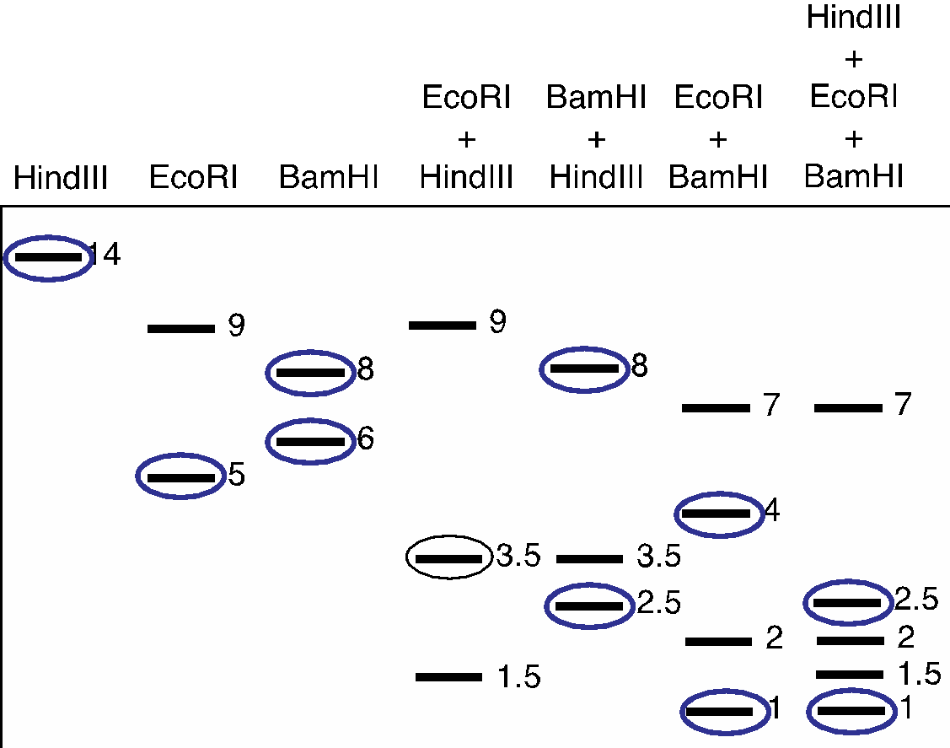

If the 3.5kb fragment from the EcoRI+HindIII digest (circled above) is made radioactive and used as a probe in a Southern blot of this gel, which bands do you expect to appear radioactive on an autoradiogram **(**circle the bands that will be seen on an autoradiogram; **5 points)**?